**МОДУЛЬ 4. Взаимоотношения в семье, с друзьями**

План – конспект урока английского языка в 5 классе

по учебнику Е.Ю.Ваулиной, Д.Дули, О.Е.Подоляко, В.Эванс «Английский в фокусе»

по теме «Американские«телесемьи» (с.61) **Unit 4d**

**Тема урока:** Американские «телесемьи».

**Тип урока:** комбинированный

**Класс: (5 «К», 5 «Б»,)**

**Урок -34**

**Цель**: развитие навыков распознавания и употребления изученной ранее тематической лексики, развитие мотивации учащихся к даль­нейшей работе по теме.

**Планируемые результаты:**

***Предметные УУД:*** научиться делать сообщение об известных телесемьях, развивать лексические и грамматические навыки в рамках темы во всех видах речевой деятельности; развивать умения, составляющие лингвистическую компетенцию: прогнозирование содержания по заголовку и иллюстрациям, использование ассоциативного ряда как приема запоминания новых слов.

***Метапредметные УУД:***

***Личностные****:* смыслообразование; формирование мотивационной основы учебной деятельности, включающей социальные, учебно-познавательные и внешние мотивы.

***Регулятивные:*** самостоятельно ставить новые учебные цели и задачи

***Познавательные:*** осуществлять сравнение, классификацию, самостоятельно выбирая основания и критерии для указанных логических операций

***Коммуникативные:*** строить монологическое контекстное высказывание

Формы организации познавательной деятельности: фронтальная, индивидуальная, парная.

**Оборудование:** учебник, презентация, аудиозапись, раздаточный материал.

**Ход урока**

1. **Организационный момент. Приветствие.**

T: Good morning boys and girls. I’m very glad to see you. How are you?

P: I’m fine/OK/ well/not so bad.

1. **Постановка цели и задач урока. Мотивация учебной деятельности учащихся. (Слайд 2)**

Do you know these characters? Who are they? I think you are ready to say what the topic of the lesson is.

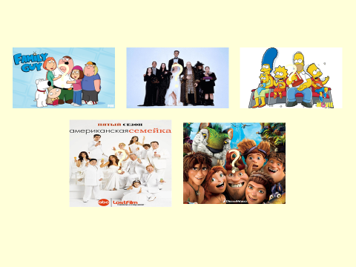

Today we are going to speak about families, but we’ll speak about unusual families. They’ll be American and Russian TV families. We’ll read texts, listen to music, do some exercises, describe pictures.

1. **Актуализация знаний.**

**3.1. Проверка домашнего задания.**

Упр. 3 стр. 60 – рассказ о знаменитости.

**3.2. Речевая зарядка. Повторение лексики. Brainstorming.**

T: Look at the blackboard and write as many words as you can: (**слайд №3-4**)

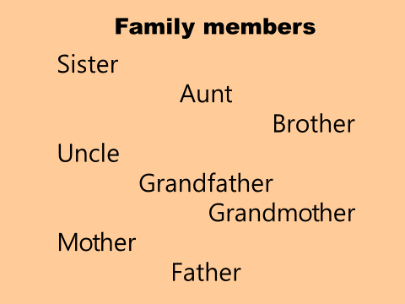

**3.3. Работа в парах.**

T: Let’s remind all family members. (**Слайд 5)**

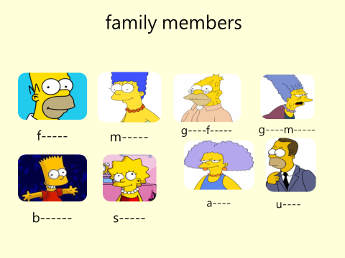

T: The next task is to make the words.

|  |  |
| --- | --- |
| ooCl | Cool |
| indK | Kind |
| leverC | Clever |
| ndFriely | Friendly |
| unnyF | Funny |
| htyNaug | Naughty |
| utiBeaful | Beautiful |
| isyNo | Noisy |
|  |  |

Проверка (**слайд 6**)

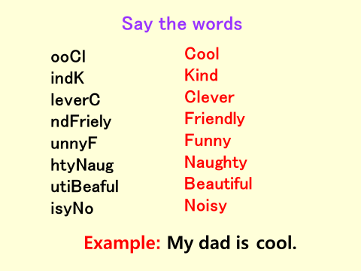

T: Make sentences with this word. Who is (cool, kind, sweet, clever, friendly, noisy, funny, naughty, caring) in your family?

P-1: My mother is sweet. P-2: My father is clever.

T: Very well! I see, all of you have done this task well.

1. **Первичное усвоение знаний. Работа с учебником.**

**4.1. Ознакомительное чтение. Упр. 1 стр. 61**

- What cartoon does it match? You are right! The Simpsons is a very popular TV show, not just in America but all over the world **(слайд 7).**

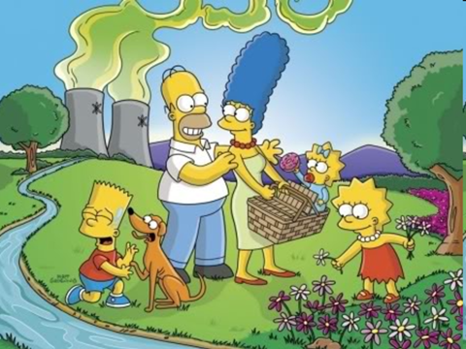

Do you like to watch this TV show? What is this text about? (About The Simpsons family)

Who are the Simpsons? How many people are there in the family? (5)

What are their names? (Lisa, Bart, Maggie, Homer, Marge)

What town/ country are they from? (Springfield/ the USA)

* Read the text and check.

T: Repeat the Simpsons` names after me, please. **(Слайд 8)**

Lisa Simpson [li:sə ] 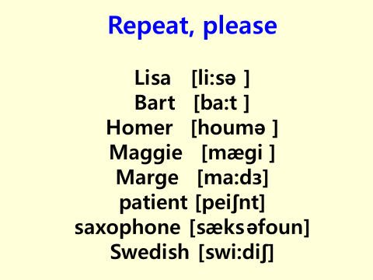 Bart Simpson [ba:t ] Homer Simpson [houmə ]

Maggie Simpson [mægi ] Marge Simpson [ ma:dз]

**4.2. Поисковое чтение.**

**-** Now match the pictures to the text.

Учащиеся повторно читают текст, подчеркивая ключевые слова, и самостоятельно выполняют задание. Учащиеся сравнивают ответы в парах.

Проверка соотнесения картинок и описаний. (A- Bart, B- Lisa, C -Maggie, D- Marge, E- Homer.)

Проверка: (**слайд 9)**

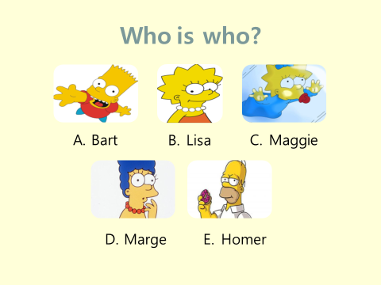

1. **Первичная проверка понимания**

**5.1. Изучающее чтение. Упр. 2, с. 61.** (Учащиеся слушают аудиозапись и заполняют пропуски в тексте)

- Read the text and fill in the missing words. Let’s listen and check your answers.

**5.2. Работа по тексту.**

* I'd like to check your memory.   
  **A) Guess who?**   
  He is tall and fat. (Homer Simpson)   
  Her hair is blue (Marge)   
  He likes comic books and skateboarding.(Bart)   
  They can play the saxophone(Lisa and Maggie)   
  She's got fair hair. (Maggie)   
  **B)** **Correct the sentences**   
  Homer Simpson is the mother of the family   
  Lisa is 10 years old   
  Bart likes eating and drinking.

Marge is 38 years old.  
The Simpsons is a sad family.  
The Simpsons is from Russia.

"The Simpsons " is a very popular TV show.

**5.3. Физминутка (видеоролик «Pinguin dance)**

1. **Первичное закрепление.**

**6.1. Работа в парах. составление мини-диалогов. Упр. 3 стр. 61**

T: Now we are going to work in pairs. You are to be ready with your answer in 5 minutes.

Учащиеся работают в парах, затем проверяем составленные мини-диалоги. **(слайд 10)**

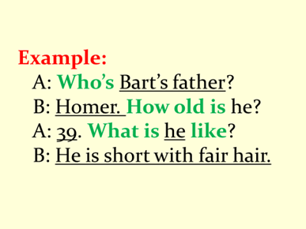

Пример:

A: Who’s Bart’s father?

B: Homer. How old is he?

A: 39. What is he like?

B: He is short with fair hair.

1. **Контроль усвоения. Составление рассказа. (слайд 11)**

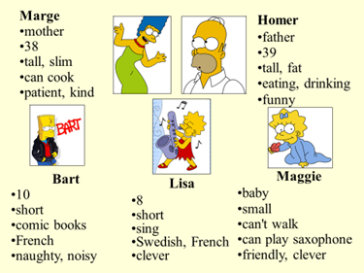

Учащиеся составляют рассказ опираясь на factfile.

Example:

**Marge**

* **mother**
* **38**
* **tall, slim**
* **can cook**
* **patient, kind**

Marge Simpson is the mother of the family. She is 38 years old. She is tall and slim. She can cook. She is very patient and kind.

1. **Домашнее задание.**

* At home you have to make a poster about your favourite TV family and write short descriptions.

(упр. 4 стр. 61 – сделать постер об известной российской телесемье и написать краткое описание всех членов семьи)

1. **Рефлексия. Подведение итогов урока.**

**-** Thank you for the lesson. Now I’d like you to say if you like the lesson or not? What was your favourite task? Now let’s see how you are feeling now.

*I’m fine/not so bad/not so well/ so-so/ terrible/ sleepy/ excited.*

*I’m in a good/bad mood.*

*I feel like singing and dancing.*

**Today I’ve learnt……….**

**Now I know…………….**

**Now I can………………**

T:You are great! Thank you very much. You all worked very hard. And I want to put marks. Everybody gets good marks.

The lesson is over. Goodbye.

**ПРИЛОЖЕНИЕ**

**Карточки:**

1. Homer Simpson is the mother of the family
2. Lisa is 10 years old
3. Bart likes eating and drinking.
4. Marge is 38 years old.
5. The Simpsons is a sad family.
6. The Simpsons is from Russia.
7. "The Simpsons " is a very popular TV show
8. Homer Simpson is the mother of the family
9. Lisa is 10 years old
10. Bart likes eating and drinking.
11. Marge is 38 years old.
12. The Simpsons is a sad family.
13. The Simpsons is from Russia.
14. "The Simpsons " is a very popular TV show
15. Homer Simpson is the mother of the family
16. Lisa is 10 years old
17. Bart likes eating and drinking.
18. Marge is 38 years old.
19. The Simpsons is a sad family.
20. The Simpsons is from Russia.
21. "The Simpsons " is a very popular TV show
22. Homer Simpson is the mother of the family
23. Lisa is 10 years old
24. Bart likes eating and drinking.
25. Marge is 38 years old.
26. The Simpsons is a sad family.
27. The Simpsons is from Russia.
28. "The Simpsons " is a very popular TV show

Приложение 2 (дополнительно)

How much do you know about the Simpsons Family? Read the sentences and circle the correct options. The picture below might help you.

___ | 25



**1. Bart is Lisa’s**

**a)** son **b)** brother

**2. Marge is Homer’s**

**a)** sister **b)** wife

**3. Clancy is Selma’s**

**a)** father **b)** uncle

**4. Abraham is Mona’s**

**a)** husband **b)** brother

**5. Maggie is Ling’s**

**a)** cousin **b)** sister

**6. Lisa is Patty’s**

**a)** aunt **b)** niece

**7. Homer is Abraham’s**

**a)** father **b)** son

**8. Selma is Ling’s adoptive**

**a)** mother **b)** daughter

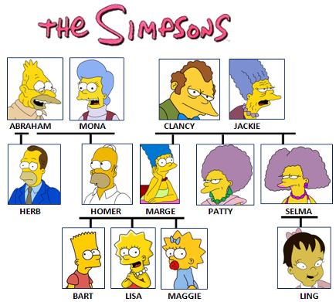

**9. Bart is Herb’s**

**a)** nephew **b)** uncle

**10. Maggie is Marge’s**

**a)** daughter **b)** mother

**11. Herb is Marge’s**

**a)** brother **b)** brother-in-law

**12. Patty is Selma’s**

**a)** sister **b)** half-sister

**13. Herb is Homer’s**

**a)** half-brother **b)** cousin

**14. Abraham is Marge’s**

**a)** father **b)** father-in-law

**15. Herb is Maggie’s**

**a)** uncle **b)** nephew

**16. Jackie is Homer’s**

**a)** mother **b)** mother-in-law

**17. Marge is Herb’s**

**a)** sister-in-law **b)** sister



**18. Homer and Marge are Lisa’s**

**a)** fathers **b)** parents

**19. Homer is Clancy’s**

**a)** son-in-law **b)** son

**20. Bart and Lisa are Maggie’s**

**a)** brothers **b)** siblings

**21. Abraham is Lisa’s**

**a)** grandfather **b)** father-in-law

**22. Bart and Lisa are Marge’s**

**a)** children **b)** grandchildren

**23. Maggie is Jackie’s**

**a)** grandmother **b)** granddaughter

**24. Marge is Mona’s**

**a)** daughter-in-law **b)** daughter

**25. Clancy and Jackie are Bart’s**

**a)** parents-in-law **b)** grandparents

